**Transport properties of cubic zero-moment ferromagnetic Mn2RuXGa films**

*Naganivetha Thiyagarajah, Yong Chang Lau, Karsten Rode, Davide Betto, Kiril Borisov, M. Venkatesan, J.M.D Coey, Plamen S. Stamenov*

*CRANN, AMBER, and School of Physics, Trinity College Dublin, Ireland*

**Abstract**

**Introduction**

Cubic ferromagnetic Heusler compounds are a family of magnetic materials that often exhibit higher spin polarization at the Fermi level than binary ferromagnetic 3d alloys1. Some of the materials are half-metals with a gap in the spin-polarized density of states for one spin band which should make them ideal candidates for spin-valves or MTJs2-5. Since the prediction by van Leuken and de Groot in 1995, of a half-metallic material with two inequivalent magnetic sublattices whose moments cancel out 6, researchers have worked on fabricating such a material. While electronic structure calculations predicted several such compounds7-9, fabrication of such materials had failed8, 10. In 2014, Kurt *et al* reported the growth of thin films of Mn2Ru0.5Ga, which was identified as a zero-moment ferrimagnet with high spin polarization and showed evidence of half-metallicity11.

Here we report on the temperature, composition and thickness dependent transport properties of Mn2RuxGa (MRG), which are at or near compensation point (0.4 < x < 0.6).

**Experimental details**

MRG films of thickness 4 – 70 nm were grown on MgO (001) substrates by dc-magnetron sputtering at 250⁰C substrate temperature and base pressure 3 × 10-8 Torr in a Shamrock deposition system. The films were co-sputtered from a Mn2Ga target and Ru target, and the Ru composition was controlled by keeping the Mn2Ga sputtering power fixed while varying that of Ru. The MRG films were capped with a 3 nm thick layer of AlOx to prevent oxidation. The crystal structure and lattice parameters were determined by θ - 2θ and reciprocal space map (RSM) scans using a BRUKER D8 diffractometer with a Cu-Kɑ source. The Ru concentration was calculated based on the critical angle of x-ray reflectivity measurement12 and correlated with the relative sputtering power of the Mn2Ga and Ru targets. Magnetization measurements were made using a Quantum Design superconducting quantum interference device (SQUID) magnetometer. The transport measurements were conducted on unpatterned MRG films in a physical properties measurement system (PPMS) for temperatures from 10K to 400K. The maximum applied magnetic fields, µ0H, for the two systems were 5T and 14T respectively. We also incorporated the MRG as the hard layer into a pseudo spin valve with the structure, MgO/ Mn2Ru0.5Ga (15)/Cu (2.8)/[Co (0.2)/Pd (0.6)] x 6/Ta (3 nm) in order to investigate the spin dependent transport. The MRG layer was grown at 250⁰C, then cooled down to room temperature, and was subsequently transferred to a different deposition chamber for the Cu/[Co/Pd] multilayer deposition. Atomic force microscopy measurements of the MRG film showed a roughness of ~0.2 nm, free of pinholes.

**Results and discussion**

The crystal structure of the cubic MRG films with different thickness and compositions were probed using 2θ - θ X-ray diffraction (XRD) as shown in Figure 1(b). The out-of-plane lattice parameter, a⊥, was found to be between 0.598 and 0.618 nm, depending on the Ru concentration and film thickness (insert of Figure 1). The in-plane lattice 1parameter, a∥, determined from reciprocal space maps was found to be 0.596 nm for all samples which is closely matched to the 45⁰ rotated in-plane lattice parameter of MgO which is 0.5955 nm. This confirms the cubic nature of the MRG films with a slight tetragonal out-of-plane distortion (a⊥/a∥ ratio between 1.003 and 1.03).

Figure 2(a) shows the magnetization measurement at 300K of a typical MRG film of 70nm near compensation of the magnetic sublattices. Clear out-of-plane anisotropy with a large coercivity of 1.2T is evident. A small soft in-plane component is also clearly visible. As the Ru concentration is reduced from x = 0.64, the magnetization reduces, until it falls practically to zero (12 kAm-1 or 0.07µB/f.u.) at x = 0.55 as shown in Figure 2(b). On further reduction of Ru the magnetization again increases. For clarity, this is denoted as a negative magnetization, coincident with the reversal in sign in the extraordinary Hall effect (EHE) measurements. From the EHE measurements of the same set of samples with varying Ru content, we extracted the coercivity, µ0HC­, and spontaneous Hall angle (SHA) (Figure 2(c)). As the magnetization approaches zero the coercivity clearly diverges (the sample closest to compensation at room temperature could not be saturated at an applied field of 5T). The recorded spontaneous Hall angles for samples near compensation (~5%) are about a magnitude larger than those reported for other 3d ferromagnets at room temperature (0.2-0.3%)13 and comparable to SHA angles recorded for amorphous rare earth transition metal alloys14.

As shown in Figure 1, the MRG films are increasingly strained as the thickness of the film is reduced. It has been predicted that the magnetization may depend strongly on the lattice distortion15 since this would have an effect on the interaction between neighbouring atoms. We prepared Mn2Ru0.5Ga samples of different thickness from 70 nm down to 4nm and measured their EHE response at different temperatures from 400K to 10K in the PPMS. Figure 3(a) shows a typical EHE response over the temperature range for the sample of 34 nm thickness. It can be seen that the coercivity diverges to >9T at 350K and the sign of the EHE loop reverses at 300K. This indicates that the compensation temperature lies between 300 and 350K. By plotting the derivative of the Hall resistance w.r.t temperature, dRXY/dT, as shown in Figure 3(b), it can be seen that this compensation temperature shifts to lower temperatures as the thickness of the MRG is reduced. Since the compensation is achieved by the cancelling out of the moment of the two inequivalent Mn sublattices, this shift in compensation temperature may be due to the slightly different temperature dependence of the two sublattices. As with samples with different Ru content, the extracted coercivity shows maximum values near the compensation temperature for each thickness as shown in Figure 3(c).

Finally we measured the magnetoresistance (MR) properties of the MRG/Cu/[Co/Pd] samples at different temperatures from 2K to 300K. The MR was measured on unpatterned films in the current-in-plane configuration. A MR effect was cleared observed at 2K, and persists even at room temperature as shown in Figure 4. The observed MR is however quite low (~ 0.15%) even at 4K which may be due to two effects: Firstly considering the transfer between separate deposition chambers for the MRG and Cu/[Co/Pd] layers, some interfacial contamination or oxidation of the manganese can be expected. Secondly, based on the results shown for the thickness dependence of the MRG films, as discussed above, we find that the films are increasingly strained as the thickness of the film is reduced. This causes a variation in the spin-dependent transport properties and compensation of the two magnetic sub lattices, compared to the thicker films. Furthermore, GMR is lost relatively quickly due to domain structuring and imperfect rotation of the magnetisation in the two electrodes, as evidenced by dispersed switching field range as shown in the electronic transport (Figure 3(a), and Figure 4).

**Conclusion**

**Acknowledgements**

**References**

1. T. Graf, (Elsevier, 2013), Vol. 21, pp. 1 - 75.

2. J. Kübler, A. R. William and C. B. Sommers, Physical Review B **28** (4), 1745 (1983).

3. Y. K. Takahashi, A. Srinivasan, B. Varaprasad, A. Rajanikanth, N. Hase, T. M. Nakatani, S. Kasai, T. Furubayashi and K. Hono, Applied Physics Letters **98** (15), 152501-152503 (2011).

4. W. Wang, H. Sukegawa, R. Shan, S. Mitani and K. Inomata, Applied Physics Letters **95** (18), 182502-182503 (2009).

5. S. Tsunegi, Y. Sakuraba, M. Oogane, K. Takanashi and Y. Ando, Applied Physics Letters **93** (11), 112506 (2008).

6. H. van Leuken and R. A. de Groot, Physical Review Letters **74** (7), 1171-1173 (1995).

7. S. Wurmehl, H. C. Kandpal, G. H. Fecher and C. Felser, Journal of Physics Condensed Matter **18** (27), 6171-6181 (2006).

8. X. Hu, Advanced Materials **24** (2), 294-298 (2012).

9. I. Galanakis, P. Mavropoulos and P. H. Dederichs, Journal of Physics D: Applied Physics **39** (5), 765-775 (2006).

10. E. Şaşıoğlu, Physical Review B **79** (10), 100406 (2009).

11. H. Kurt, K. Rode, P. Stamenov, M. Venkatesan, Y. C. Lau, E. Fonda and J. M. D. Coey, Physical Review Letters **112** (2), 027201 (2014).

12. L. G. Parratt, Physical Review **95** (2), 359-369 (1954).

13. J. W. F. Dorleijn, Philips Res. Rep. **31** (1976).

14. T. W. Kim, S. H. Lim and R. J. Gambino, Journal of Applied Physics **89** (11), 7212-7214 (2001).

15. unpublished.

**Figure captions**

FIG 1: (a) Schematic of the ferromagnetic structure of the C1b­ Mn2RuxGa, Ga occupies the 4*b* sites, Mn occupies two inequivalent sites, 4*a* and 4*c* sites, and Ru occupies some of the remaining 4*d* sites. The Mn in the 4*a* and 4*c* sites carries the opposite magnetic moments. (b) XRD of thin films of Mn2Ru0.5Ga of thicknesses from 70 nm to 4nm grown on MgO substrates. Inset shows the dependence of the out-of-plane lattice parameter (a⊥) on the thickness of the film, indicating that the substrate induced strain is increasingly relaxed as the thickness increases

FIG 2: (a) In-plane and out-of-plane magnetization loops of Mn2Ru0.5Ga sample of thickness 70 nm, measured in a SQUID magnetometer at 300K. (b) Extracted magnetization at 300K (in µB/f.u.), for samples of thickness 70nm with different Ru composition (0.5 < x < 0.6). The change of sign of the magnetization was established by EHE sign reversal at compensation. (c) Coercive field and spontaneous Hall angle as a function of Ru composition, extracted from EHE measurements carried out at 300K, for the same MRG samples as in (b).

FIG3: (a) EHE loops measured at various temperatures between 10K – 400K, for Mn2Ru0.5Ga sample of thickness 34 nm, which illustrates the change of sign of the spontaneous hall coefficient between 300K and 350K (the curves are offset vertically for clarity). (b) Variation of compensation temperature with the thickness of MRG film of same Ru concentration, given by the derivative of the resistance w.r.t temperature. The compensation temperature shifts to lower temperatures with decreasing thickness. (c) Extracted coercive field and (d) spontaneous Hall angle as a function of temperature for samples with the same Ru concentration (x ~ 0.5) and various thicknesses from 70 nm to 4 nm.

FIG 4: MR of a pseudo spin valve Mn2Ru0.5Ga(15)/Cu (2.8)/[Co (0.2)/Pd (0.6)]x6/Ta (3 nm) measured at various temperatures. The curves have been offset vertically for clarity. The inset shows the temperature variation of the GMR contribution with a fit to T0.5dependence.

Figure 1

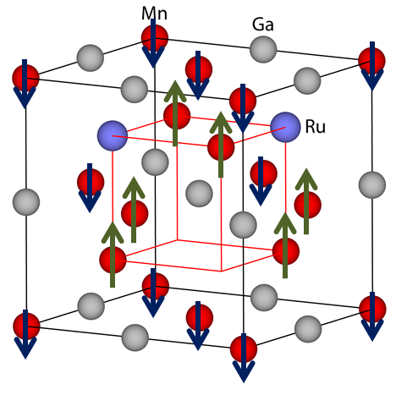

Figure 2

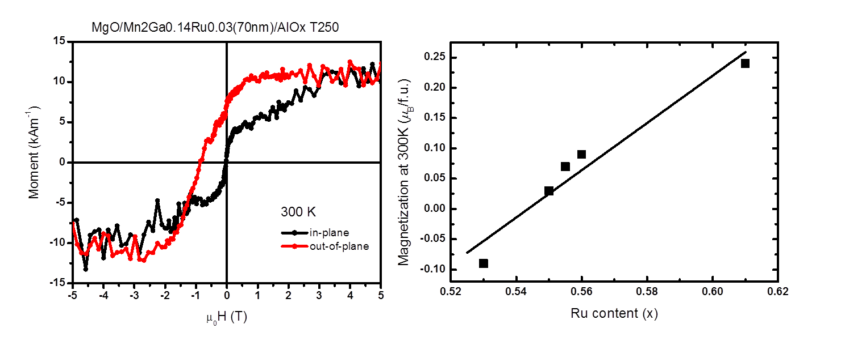



Figure 3

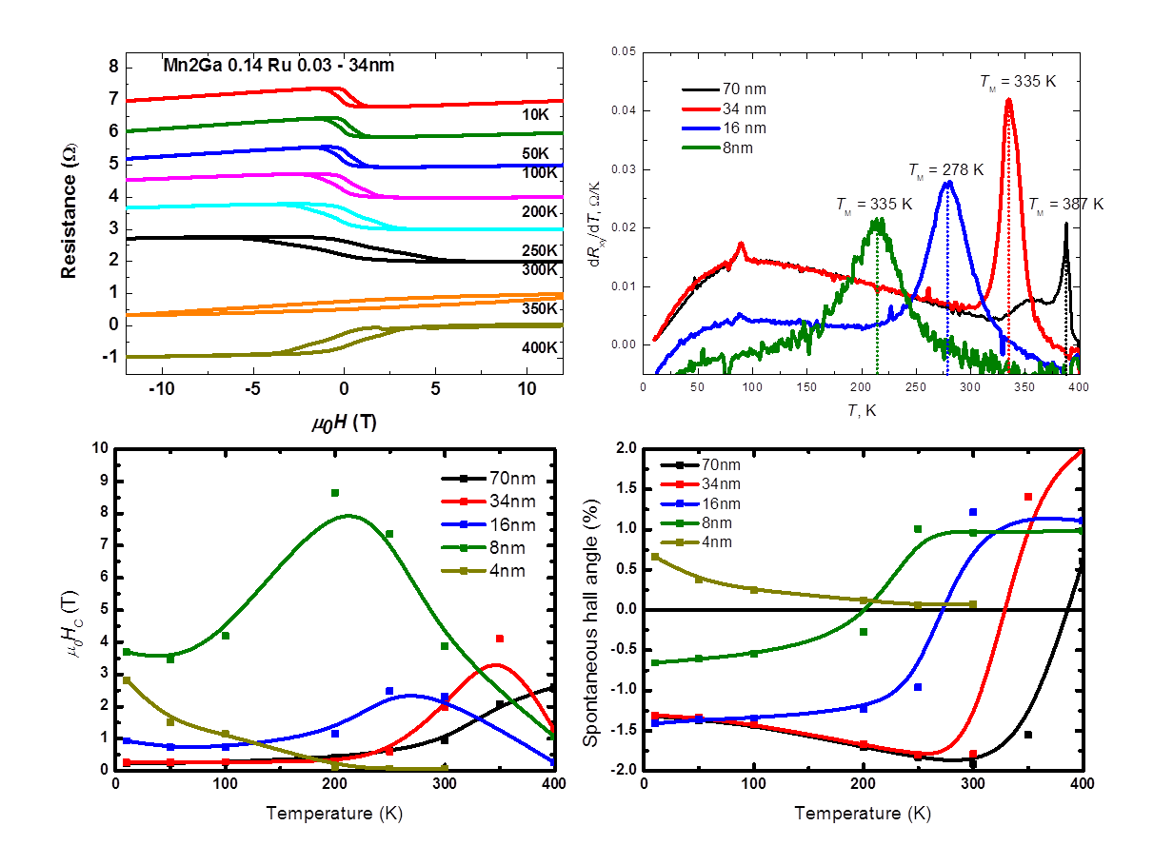

Figure 4

